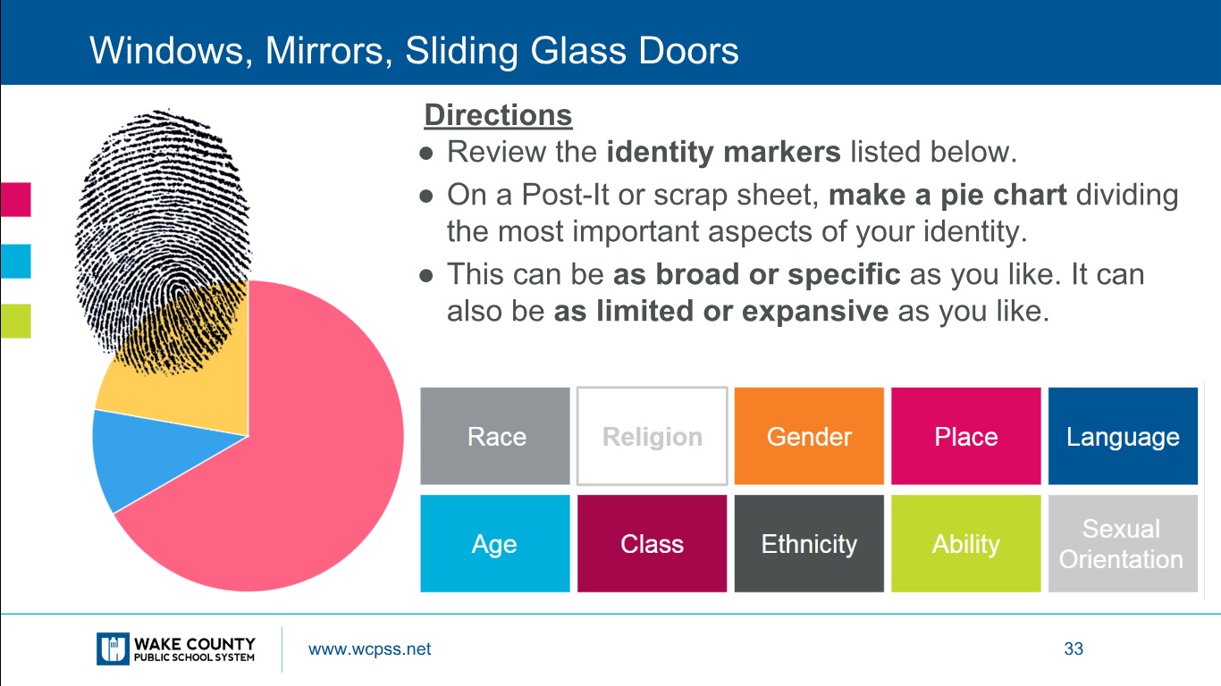

Your pod will be assigned a character. With that character, create a pie graph using the identity markers to analyze who they are as a whole person. What percentage goes toward each section? Reference (with pg number) why you think that is the case for each section of the pie graph.

- Amir
- Baba
- Hassan
- Ali
- Rahim Khan

