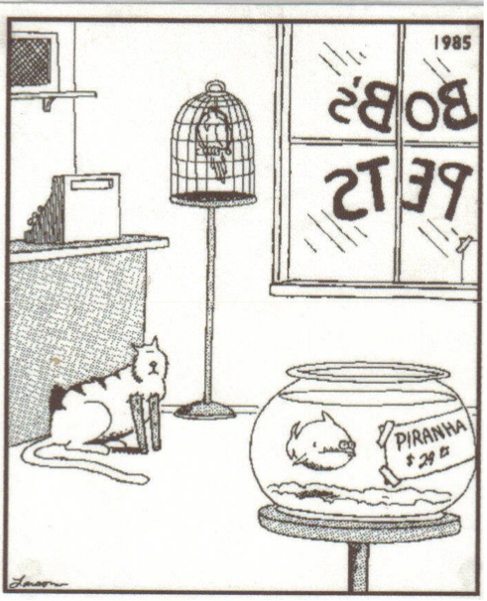

What had just happened in this picture? How do you know? Make a statement, proof it, and then explain.

